Pizza Sales SQL Queries

A. KPI’s

- Total Revenue:
SELECT SUM(total_price) AS Total_Revenue
FROM PizzaDS ;
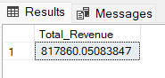
- Average Order Value:
SELECT SUM(total_price)/COUNT(DISTINCT order_id) AS Avg_Order_Value
FROM PizzaDS;
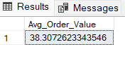
- Total Pizza Sold:
SELECT SUM(quantity) AS Total_Pizza_Sold
FROM PizzaDS;
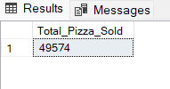
- Total Orders:
SELECT COUNT(DISTINCT order_id) AS Total_Orders
FROM PizzaDS;
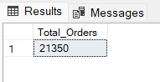
- Average Pizza per Order:
SELECT CAST(CAST(SUM(quantity) AS DECIMAL(10,2))/CAST(COUNT(DISTINCT order_id) AS DECIMAL(10,2)) AS DECIMAL(10,2)) AS Avg_Pizza_Per_Order
FROM PizzaDS;
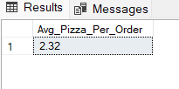
B. CHARTs
- Daily Trend for Total Orders:
SELECT DATENAME(DW, order_date) AS Order_Day, COUNT(DISTINCT order_id) AS Total_Order
FROM PizzaDS
GROUP BY DATENAME(DW, order_date);
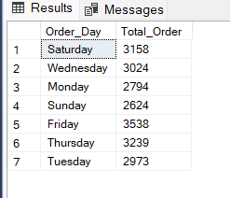
- Monthly Trends for Total Orders:
SELECT DATENAME(MONTH, order_date) AS Order_Month, COUNT(DISTINCT order_id) AS Total_Order
FROM PizzaDS
GROUP BY DATENAME(MONTH, order_date)
ORDER BY Total_Order DESC;
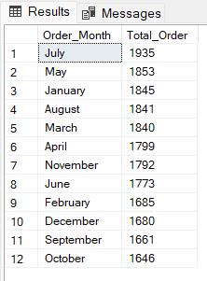
- Percentage of Pizza Sales by Category:
SELECT pizza_category, SUM(total_price) AS Total_Sales, SUM(total_price) * 100 /
(SELECT SUM(total_price) FROM PizzaDS WHERE MONTH(order_date) = 1) AS Percentage_Total_Sales
FROM PizzaDS
WHERE MONTH(order_date) = 1
GROUP BY pizza_category;
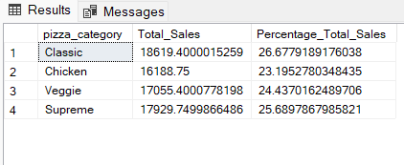
- Percentage Sales by Pizza Size:
SELECT pizza_size, SUM(total_price) AS Total_Sales, CAST(SUM(total_price) * 100 /
(SELECT SUM(total_price) FROM PizzaDS WHERE DATEPART(quarter, order_date) = 1) AS DECIMAL(10,2)) AS Percentage_Total_Sales
FROM PizzaDS
WHERE DATEPART(quarter, order_date) = 1
GROUP BY pizza_size
ORDER BY Percentage_Total_Sales DESC;
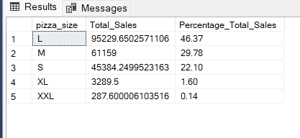
- Top 5 Best-Selling Pizza sold by Revenue, Quantity & Total Orders:
Revenue =
SELECT TOP 5 pizza_name, SUM(total_price) AS Total_Revenue
FROM PizzaDS
GROUP BY pizza_name
ORDER BY Total_Revenue DESC;
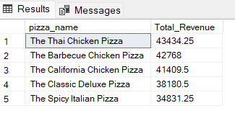
Quantity =
SELECT TOP 5 pizza_name, SUM(quantity) AS Total_Quantity
FROM PizzaDS
GROUP BY pizza_name
ORDER BY Total_Revenue DESC;
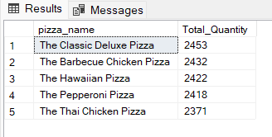
Total Orders =
SELECT TOP 5 pizza_name, COUNT(DISTINCT order_id) AS Total_Orders
FROM PizzaDS
GROUP BY pizza_name
ORDER BY Total_Orders DESC;
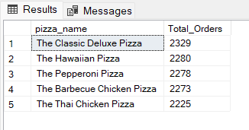
- Bottom 5 Worst-Selling Pizza sold by Revenue, Quantity & Total Orders:
Revenue =
SELECT TOP 5 pizza_name, SUM(total_price) AS Total_Revenue
FROM PizzaDS
GROUP BY pizza_name
ORDER BY Total_Revenue ASC;
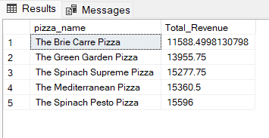
Quantity =
SELECT TOP 5 pizza_name, SUM(total_price) AS Total_Revenue
FROM PizzaDS
GROUP BY pizza_name
ORDER BY Total_Revenue ASC;
Quantity =
SELECT TOP 5 pizza_name, SUM(quantity) AS Total_Quantity
FROM PizzaDS
GROUP BY pizza_name
ORDER BY Total_Quantity ASC;
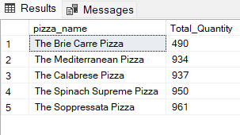
Total Orders =
SELECT TOP 5 pizza_name, COUNT(DISTINCT order_id) AS Total_Orders
FROM PizzaDS
GROUP BY pizza_name
ORDER BY Total_Orders ASC;
